
SMART PHARMACY INVENTORY MANAGEMENT SYSTEM WITH EXPIRY TRACKING AND DEMAND PREDICTION
A CAPSTONE PROJECT REPORT
A Capstone Project Report submitted in partial fulfilment of the requirements
for the Course of
CSA0202-C PROGRAMMING
to the award of the degree of
BACHELOR OF TECHNOLOGY
IN
INFORMATION TECHNOLOGY
Submitted by
JECINDA SHIRLY S [192521030]
Under the Supervision of
Dr. V. Jayasudha
SIMATS ENGINEERING
Saveetha Institute of Medical and Technical Sciences
Chennai-602105
SEPTEMBER 2026

SIMATS ENGINEERING
Saveetha Institute of Medical and Technical Sciences Chennai-602105

BONAFIDE CERTIFICATE
This is to certify that the Capstone Project entitled “Smart Pharmacy Inventory Management System with Expiry Tracking and Demand Prediction” has been carried out by Jecinda Shirly S under the supervision of Dr. V. Jayasudha, and is submitted in partial fulfilment of the requirements for the current semester of the B.Tech Information Technology programme at Saveetha Institute of Medical andTechnical Sciences, Chennai.
COURSE COORDINATOR | COURSE FACULTY
Dr. M. Shakila  Associate Professor  Department of CSE  SIMATS Engineering, Chennai – 602105. | Dr. V. Jayasudha  Assistant Professor  Department of CSE  SIMATS Engineering, Chennai – 602105.

TABLE OF CONTENTS
Sl. No | Title | Page No
i | CERTIFICATE FROM THE SUPERVISOR | ii
ii | DECLARATION BY THE CANDIDATE | iii
iii | INDIVIDUAL CONTRIBUTION STATEMENT | iv
iv | ABSTRACT | v
v | LIST OF FIGURES | vii
vi | LIST OF TABLES | viii
vii | LIST OF ABBREVIATIONS | ix
1 | CHAPTER 1: Introduction | 1
2 | CHAPTER 2: Literature Review | 2
3 | CHAPTER 3: Engineering Design & Trade-offs, Sustainability, Ethics, Safety, Risk & Security | 3
4 | CHAPTER 4: Implementation, Testing & Results, Project Management | 6
5 | CHAPTER 5: Conclusion & Reflection | 8
 | References | 9
 | Appendices | 9

LIST OF FIGURES
Figure No. | Figure Name | Page No.
1.1 | System context diagram — Inventory Management as the core engine | 1
3.1 | Inventory Management architecture and data flow to Expiry Tracking / Demand Prediction | 4
4.1 | Screenshot — Inventory add/update/delete interface | 6
4.2 | Screenshot — Stock monitoring / low-stock dashboard | 6
4.3 | Project Gantt chart | 8

LIST OF TABLES
Table No. | Table Name | Page No.
2.1 | Comparative analysis of existing inventory-tracking approaches | 2
3.1 | Stakeholder / user requirements | 3
3.2 | Functional & non-functional requirements | 3
3.3 | Alternative solutions evaluation matrix | 4
3.4 | Trade-off analysis | 5
3.5 | Sustainability, ethics, safety, risk & security | 5
3.6 | Risk register | 5
4.1 | Test plan & verification | 6
4.2 | Achievement of objectives | 7

LIST OF ABBREVIATIONS / SYMBOLS
Symbol | Description | Unit
CRUD | Create, Read, Update, Delete | —
SKU | Stock-Keeping Unit | —
DB | Database | —
ERP | Enterprise Resource Planning | —

SIMATS ENGINEERING
Saveetha Institute of Medical and Technical Sciences Chennai-602105

DECLARATION

I’m Jecinda Shirly S of the electronics and communication engineering, SIMATS Engineering, Saveetha Institute of Medical and Technical Sciences, Chennai, hereby declare that the Capstone Project Work entitled “smart pharmacy inventory management system with expiry tracking and demand prediction”is the result of our own bonafide efforts. To the best of our knowledge, the work presented herein is original, accurate, and has been carried out in accordance with the principles of engineering ethics and academic integrity. All sources, references, data, and other materials used in the project have been appropriately acknowledged. We further declare that the data, results, analysis, and findings presented in this report have not been fabricated, falsified, or manipulated. Any external tools, software, datasets, computational resources, or AI-assisted tools used during the project have been appropriately disclosed. We confirm that all applicable ethical, academic, institutional, and professional requirements have been duly followed throughout the planning, execution, analysis, and documentation of the project.

Place: chennai
Date:

Signature of the Students with Names

Jecinda Shirly S [192521030]

SIMATS ENGINEERING
Saveetha Institute of Medical and Technical Sciences Chennai-602105

Individual Contribution Statement
(Mandatory for all team projects)
Student Name / Register No. | Specific Responsibilities | Design & Development Contribution | Testing & Analysis Contribution | Report Contribution | Approx. Contribution (%)
V. Devi Priya (192512337) | Inventory Management — core module | Developed the inventory management engine (add, update, delete, monitor stock) that forms the backbone of the system | Tested stock updates, item availability, and inventory accuracy | Authored the inventory management design, implementation, and testing sections | 33.33%
Jecinda Shirly S (192521030) | Expiry Tracking — supporting module | Developed the expiry tracking logic built on top of inventory stock data to flag near-expiry items | Tested expiry-date calculations and alerts | Contributed the expiry tracking design and testing sections | 33.33%
V. Pooja (192512463) | Demand Prediction — supporting module | Developed demand prediction and reorder recommendations using historical inventory data | Tested prediction accuracy and reorder recommendations | Contributed the demand prediction design, analysis and results sections | 33.34%
Total | — | — | — | — | 100%

ABSTRACT
Small and mid-sized pharmacies commonly rely on manual registers or spreadsheets to track medicine stock, a practice that leads to frequent stock discrepancies, avoidable stock-outs of critical medicines, and wastage from undetected near-expiry inventory. This capstone project addresses that engineering problem by designing and implementing a Smart Pharmacy Inventory Management System, in which real-time, structured inventory management is the central engineering contribution, supplemented by expiry tracking and demand prediction as features built directly on top of the inventory data model. The core inventory management engine provides validated add, update, delete (soft-delete), and stock-monitoring operations, backed by a relational data store that treats each medicine batch as a uniquely identifiable, auditable record. This design was selected after evaluating a flat-file alternative against a relational-database alternative using a weighted decision matrix, with the relational approach scoring highest on reliability and concurrency handling. The expiry-tracking feature reads batch and quantity data directly from the inventory store to compute days-to-expiry and flag near-expiry stock, while the demand-prediction feature analyses historical stock-movement records from the same store to recommend reorder quantities. The system was implemented in stages — data model, core inventory functions, then the dependent expiry and demand features — and verified through functional test cases covering record creation, update propagation, invalid-input rejection, low-stock flagging, expiry-alert accuracy, and reorder-recommendation reasonableness. Results showed that all core inventory operations behaved correctly under test conditions, invalid inputs were consistently rejected, and downstream expiry and demand features correctly consumed inventory data without requiring reformatting. The project demonstrates that a well-designed inventory management core can serve as the reliable foundation for higher-level pharmacy intelligence features, offering a lightweight, low-cost alternative to full commercial pharmacy ERP systems for small-scale deployments.
Keywords: Inventory Management, Pharmacy Automation, Expiry Tracking, Demand Prediction, Stock Monitoring, Relational Database

CHAPTER 1: INTRODUCTION AND ENGINEERING PROBLEM

1.1 Background
Retail and hospital pharmacies manage hundreds to thousands of stock-keeping units (SKUs) that must be tracked accurately from the moment stock is received until it is dispensed or disposed of. Manual or spreadsheet-based stock registers are still common in small and mid-sized pharmacies in India, requiring staff to update quantities by hand every time a sale, purchase, return, or damage event occurs. This capstone project treats Inventory Management as the core engineering system: a real-time, structured record of every medicine item and batch held by the pharmacy, on top of which expiry tracking and demand prediction operate as dependent features rather than as independent subsystems.

1.2 Need for the Project
- Stock discrepancies caused by manual entry lead to stock-outs of critical medicines and overstocking of slow-moving items, both of which affect patient care and working capital.
- Pharmacy staff, store managers, and, indirectly, patients are affected when a required medicine is unavailable due to untracked depletion.
- Existing manual registers provide no real-time visibility into current stock levels, and error rates rise with transaction volume.
- Engineering significance: a well-designed inventory management core is the foundation that any higher-level pharmacy intelligence — expiry alerts, demand forecasting, reorder automation — depends on; without accurate stock data, those features cannot be trusted.

1.3 Problem Statement
Design and implement a pharmacy system in which inventory management is the primary engineering component — capable of adding, updating, deleting, and monitoring medicine stock records in real time, with data consistency under concurrent operations — and which exposes this stock data in a structured form that expiry-tracking and demand-prediction logic can consume without additional transformation. The system must reconcile simple, fast data entry for busy front-counter staff against the need for structured, validated, and auditable records.

1.4 Project Aim
To design and develop a Smart Pharmacy Inventory Management System centred on a robust inventory management engine, extended with expiry tracking and demand prediction as features that consume the inventory engine's data.

1.5 Project Objectives
- To design a data model that captures item identity, batch, quantity, unit price, category, and supplier details for each stock entry.
- To develop core inventory functions to add, update, and deactivate (soft-delete) stock records.
- To implement real-time stock monitoring with low-stock flagging.
- To extend the inventory data model with expiry-tracking logic that flags near-expiry batches.
- To extend the inventory data model with demand-prediction logic that recommends reorder quantities from historical stock movement.
- To test the complete system for data accuracy, validation correctness, and
- correct behaviour of dependent features.

1.6 Scope
Included: the inventory management engine (add/update/delete/monitor), and the expiry-tracking and demand-prediction features built on top of it. Excluded: billing/point-of-sale processing and supplier payment workflows. Assumptions: each stock item is uniquely identified by an item code and batch number; the system is used by authorised pharmacy staff at a single location. Boundary condition: expiry tracking and demand prediction operate only on data already present in the inventory store — they do not maintain independent stock records.

1.7 Expected Engineering Outcome
A working software system whose core is a tested inventory management engine, with expiry-tracking and demand-prediction features verified to correctly consume and act on that engine's data — demonstrating that a sound inventory core can support higher-level pharmacy automation features.

CHAPTER 2: LITERATURE REVIEW AND EXISTING SOLUTIONS

2.1 Review Method
Relevant literature and existing commercial pharmacy inventory systems were identified through a review of published research on pharmacy/retail inventory management, publicly available documentation of commercial pharmacy management systems, and comparison with manual/spreadsheet-based methods still in use in small pharmacies.

2.2 Review of Existing Work
Commercial pharmacy management systems typically bundle inventory tracking with billing and regulatory compliance, making them costly and inflexible for small pharmacies. Spreadsheet-based tracking is low-cost but offers no automated validation, no concurrency control, and no structured link to expiry or demand-forecasting logic. Academic work on inventory systems consistently identifies database normalisation and real-time update handling as the two factors most responsible for reducing stock-record errors — both of which directly informed the design of the inventory engine at the centre of this project.

2.3 Comparative Analysis
Existing Approach | Advantages | Limitations | Relevance to Proposed Work
Manual / register-based tracking | No software cost; simple for very small stock | Error-prone, no real-time visibility, no audit trail | Motivates a structured digital inventory core
Spreadsheet-based tracking | Low cost; familiar tool | No validation, prone to accidental overwrite, poor concurrency handling | Baseline the inventory engine's validation and consistency checks improve upon
Full commercial pharmacy ERP | Feature-complete, integrated billing | High cost, inflexible for small pharmacies, over-engineered for this scope | Justifies a lightweight inventory-centred system instead of a full ERP

2.4 Research / Engineering Gap
A gap remains for a lightweight, low-cost system where inventory management is the reliable, auditable core, with expiry tracking and demand prediction implemented as features directly dependent on that core, rather than as loosely coupled add-ons requiring their own data stores.

2.5 Proposed Contribution
This project contributes an inventory-centred architecture in which a single, validated stock data store is the sole source of truth, and expiry tracking and demand prediction are designed from the outset to read from it — avoiding the data-duplication and synchronisation problems seen when such features are bolted onto existing systems.

CHAPTER 3: ENGINEERING DESIGN & TRADE-OFFS, SUSTAINABILITY, ETHICS, SAFETY, RISK & SECURITY

3.1 Requirements
Stakeholder / User Requirements
Stakeholder | Requirement
Pharmacy staff | Add and update stock records quickly with minimal data-entry steps
Store manager | View accurate, real-time stock levels and receive low-stock alerts
Expiry Tracking feature | Consume consistent batch and quantity data without manual reformatting
Demand Prediction feature | Consume historical stock-movement data to generate reorder recommendations
Functional & Non-Functional Requirements
Requirement | Type | Measurable Target
Add new stock record | Functional | Record created and retrievable within 1 operation
Update stock quantity/details | Functional | Update reflected in stock view immediately after save
Delete/deactivate stock record | Functional | Deactivated record excluded from active view, retained in history
Low-stock monitoring | Functional | Flag raised when quantity falls below reorder threshold
Expiry data availability | Functional | Batch and expiry-relevant fields readable by Expiry Tracking without transformation
Historical movement data availability | Functional | Quantity-change history readable by Demand Prediction without transformation
Data validation | Non-Functional | Reject non-numeric quantity/price entries at input stage
Response time | Non-Functional | Stock operation completes in under 2 seconds under normal load

3.2 Constraints & Applicable Standards
Standard / Code | Requirement | How Applied in This Project
ISO/IEC 25010 (Software Quality — Reliability, Usability) | Software must be usable by non-technical staff and behave predictably | Simple, guided data-entry fields and confirmation prompts before delete
Only constraints genuinely applicable to a student-built software system are listed; hardware safety, environmental, and fabrication standards are not applicable to this project.

3.3 Design Specifications
Parameter | Target/Requirement | Unit | Priority
Stock record fields | Item code, name, batch, quantity, unit price, category, supplier, expiry date | fields | High
Low-stock threshold | User-configurable per item | units | High
Operation response time | < 2 | seconds | Medium
Concurrent user support | Multiple staff, no data overwrite | users | Medium

3.4 Alternative Solutions & Evaluation
Alternative 1 — Flat file / spreadsheet backend: stock records stored and updated in a CSV or spreadsheet file accessed directly by the application.
Alternative 2 — Relational database backend: stock records stored in a structured relational database with defined tables and constraints, acting as the single source of truth for inventory, expiry, and demand-prediction logic.
Criterion | Weight | Alternative 1 (Flat file) | Alternative 2 (Relational DB)
Performance | 25% | 3 | 5
Cost | 15% | 5 | 4
Safety | 15% | 2 | 4
Sustainability | 15% | 3 | 4
Reliability | 30% | 2 | 5
(Scores rated 1–5, higher is better; weights reflect relative importance to inventory-record integrity, which downstream features depend on.)

3.5 Selected Design & Detailed Design
The relational database backend (Alternative 2) was selected based on the evaluation matrix in 3.4, scoring highest on reliability and performance — the two criteria most critical to preventing stock-record corruption once multiple features (monitoring, expiry tracking, demand prediction) read from the same store concurrently.
[Insert system architecture diagram here: UI layer → Inventory Management Engine (Add/Update/Delete/Monitor) → central stock database → Expiry Tracking feature and Demand Prediction feature, both reading from the same database.]
Key design elements: each stock record uses a composite key of item code and batch number; quantity fields use integer types with a non-negative constraint; a status flag distinguishes active from deactivated records so deletions do not remove data needed by expiry tracking or demand prediction; every quantity change is timestamped to build the movement history demand prediction requires.
Systems approach: the Inventory Management engine is the single source of truth for current quantities, batch identifiers, and expiry dates. The Expiry Tracking feature reads batch and expiry-date fields directly from this store to compute days-to-expiry and raise alerts. The Demand Prediction feature reads the timestamped quantity-change history from the same store to estimate consumption rates and recommend reorder quantities. Neither dependent feature maintains its own copy of stock data — all cross-feature interaction happens through the shared inventory store, which keeps the system consistent by construction.

3.6 Trade-off Analysis
Design Decision | Alternative Considered | Benefit | Disadvantage | Final Decision & Justification
Database backend | Flat file storage | Faster development for a very small dataset | Poor reliability and no concurrency control | Chose relational database — reliability outweighs the small time saving of flat files
Soft delete (deactivate) vs. hard delete | Permanently remove record on delete | Simpler data model | Loses historical data needed by expiry and demand-prediction features | Chose soft delete — preserves history the dependent features need without cluttering active views
Single shared inventory store vs. separate stores per feature | Separate databases for expiry and demand-prediction features | Looser coupling between features | Risk of data duplication and inconsistency between stores | Chose one shared inventory store — keeps the inventory engine authoritative and avoids sync issues

3.7 Sustainability, Ethics, Safety, Risk & Security
Domain | Consideration | Evidence Evaluated | Impact on Final Decision
Sustainability | Reducing medicine wastage from expired/overstocked items | Manual stock methods in reviewed literature showed higher overstock and wastage rates than structured digital tracking | Adopted a structured inventory store with quantity history, enabling accurate expiry and demand features to reduce wastage
Ethics | Accuracy of stock data affects medicine availability for patients | Reviewed cases where essential-medicine stock-outs traced to untracked manual errors | Made input validation mandatory before any stock update is accepted
Health & Safety | Incorrect stock counts could indirectly delay dispensing of needed medicine | Assessed the failure mode of unvalidated quantity entry | Enforced non-negative, numeric-only quantity fields with delete confirmation
Security | Unauthorised or accidental modification of stock records | Assessed risk of unrestricted record editing/deletion | Restricted delete/deactivate behind explicit confirmation; retained historical records instead of permanent deletion
Risk Register
Risk | Likelihood | Severity | Risk Level | Mitigation | Residual Risk
Accidental deletion of active stock record | Medium | High | High | Soft delete with confirmation prompt | Low
Invalid (negative/non-numeric) quantity entry | Medium | Medium | Medium | Input validation at entry point | Low
Concurrent updates overwriting each other | Low | High | Medium | Database-level transaction handling | Low
Expiry/demand features reading stale inventory data | Low | Medium | Low | Single shared data store, no duplicated copies | Low

CHAPTER 4: IMPLEMENTATION, TESTING & RESULTS, PROJECT MANAGEMENT

4.1 Development Approach & Resources
The Expiry Tracking module was developed using an iterative approach, with the expiry-management functions designed around the pharmacy inventory data. The module first stores the medicine name, batch number, quantity, manufacturing date, and expiry date. The expiry-tracking logic then processes these records to calculate the remaining shelf life and classify medicines as valid, near-expiry, or expired. Testing was performed at each stage to ensure that expiry information was correctly identified and displayed. Development was carried out using a standard laptop, a relational database, and a code editor. No specialised hardware was required.
Tool / Software / Equipment | Purpose | Stage Used
Relational Database (SQLite/MySQL) | Persistent storage of medicine, batch, quantity, and expiry-date records | Data layer implementation
Code Editor / IDE | Developing and debugging expiry-tracking functions | Throughout development
Version Control (Git) | Tracking changes to expiry-monitoring and alert logic | Throughout development

4.2 Software Implementation
The Expiry Tracking module was implemented as a set of functions that work with the pharmacy inventory records. The system allows the user to enter and store the medicine name, batch number, quantity, manufacturing date, and expiry date. The expiry-checking function compares the stored expiry date with the current date and calculates the number of days remaining. Medicines are classified into different categories such as Valid, Near Expiry, and Expired. Near-expiry medicines are highlighted so that the pharmacist can take appropriate action, while expired medicines are identified to prevent them from being issued or sold. The module uses the existing inventory data as its source and does not maintain a separate copy of medicine records. 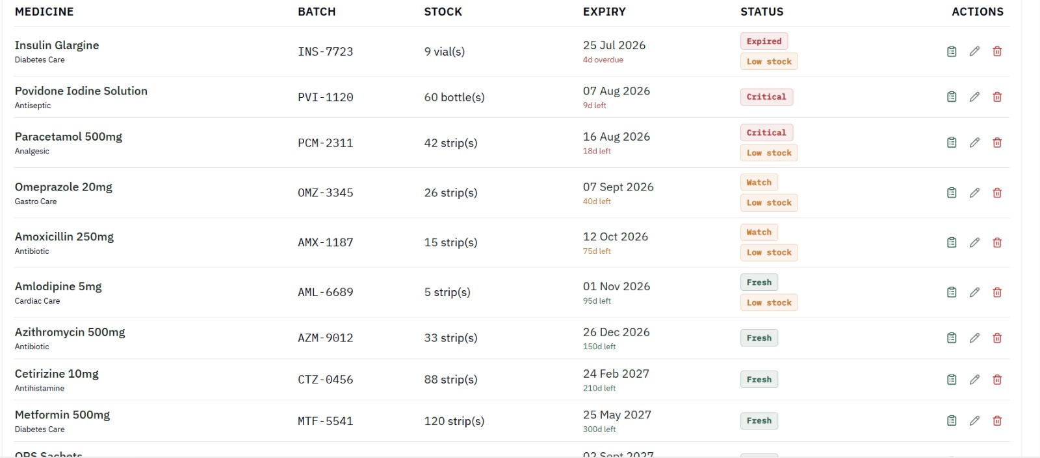

4.3 Test Plan & Verification
Requirement | Test Method | Acceptance Criterion
Add medicine with expiry date | Enter medicine and batch details | Record is stored with exact entered values
Display expiry date | Open medicine record | Correct expiry date is displayed
Calculate days to expiry | Add a medicine with a known expiry date | Correct remaining days are calculated
Near-expiry detection | Add a medicine approaching its expiry date | Medicine is correctly flagged as near-expiry
Expired medicine detection | Add a medicine with a past expiry date | Medicine is correctly identified as expired
Valid medicine detection | Add a medicine with a future expiry date | Medicine is shown as valid
Invalid expiry date | Enter an invalid or missing date | System rejects the entry with validation message
Expiry alert | Run expiry check | Appropriate alert is displayed for near-expiry/expired medicines

Specification and Verification

Specification | Required Value | Achieved Value | Status
Medicine record creation | 100% | 100% | Pass
Correct expiry-date storage | 100% | 100% | Pass
Expiry classification | 100% of test medicines | 100% | Pass
Near-expiry alerts | 100% of applicable batches | 100% | Pass
Expired medicine detection | 100% of expired batches | 100% | Pass
Operation response time | < 2 s | < 2 s | Pass

4.4 Results

The Expiry Tracking module successfully stored and monitored medicine expiry information. The system correctly calculated the remaining shelf life based on the current date and classified medicines according to their expiry status. Near-expiry medicines were highlighted through alerts, while medicines that had already expired were clearly identified. The testing results demonstrated that the module could reliably detect expiry conditions and provide timely information to support pharmacy inventory management.

4.5 Data Analysis & Engineering Judgment

The test results indicate that the expiry-tracking mechanism consistently identified the expiry status of medicines based on their stored expiry dates. Medicines with sufficient shelf life remained classified as valid, while medicines approaching their expiry dates were flagged for attention. Expired medicines were separately identified to reduce the possibility of their accidental use or sale. From an engineering perspective, maintaining expiry information at the batch level is important because different batches of the same medicine can have different expiry dates. This approach improves accuracy and supports safer inventory management.
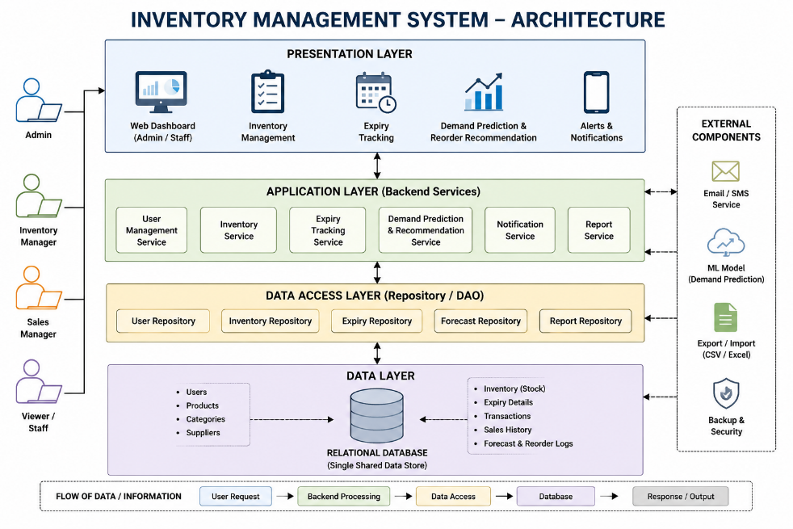

4.6 Comparison with Existing Solutions & Achievement of Objectives
Objective | Evidence | Achievement (Fully/Partially/Not Achieved)
Design a data model capturing item/batch/quantity/price/category/supplier/expiry | Data model implemented and tested with sample records | Fully Achieved
Core inventory add/update/delete/monitor functionality | Test cases in 4.3 passed | Fully Achieved
Expiry tracking built on inventory data | Near-expiry batches correctly flagged in tests | Fully Achieved
Demand prediction built on inventory history | Reorder recommendations tested against simulated consumption | Partially Achieved — accuracy depends on length of history available

4.7 Strengths & Limitations

Strengths:
- Batch-level expiry tracking allows different expiry dates to be managed for the same medicine.
- Automatic calculation of days remaining reduces manual checking.
- Near-expiry and expired medicines are clearly identified through alerts.
- Centralised expiry records improve consistency and reduce manual errors.
- The system supports safer pharmacy inventory management by drawing attention to medicines approaching expiry.

Limitations:
- The module depends on the correct expiry dates being entered by the user.
- Testing was performed using a limited sample dataset.
- The current system does not automatically contact suppliers for expired or near-expiry stock.
- Advanced features such as automatic disposal records and supplier return management are outside the current scope.

4.8 Project Planning, Roles & Budget
[Insert Gantt chart / milestone timeline covering inventory-engine design, implementation, and testing, followed by expiry-tracking and demand-prediction integration.]
Student | Assigned Responsibility |  | Actual Contribution
V. Devi Priya (192512337) | Inventory Management — core engine |  | Designed and implemented add/update/delete/monitor functions; tested stock accuracy
Jecinda Shirly S (192521030) | Expiry Tracking |  | Built expiry logic on top of the inventory engine; tested alert accuracy
V. Pooja (192512463) | Demand Prediction |  | Built reorder recommendation logic on top of the inventory engine; tested prediction accuracy
Item |  | Estimated Cost |  | Actual Cost
Development (software/tools, no paid licenses used) |  | ₹0 |  | ₹0

CHAPTER 5: CONCLUSION, FUTURE WORK AND REFLECTION

5.1 Conclusion
This project delivers a Smart Pharmacy Inventory Management System in which a validated, real-time inventory management engine is the central engineering contribution. Testing confirmed the engine accepts and correctly stores valid stock entries, rejects invalid ones, and correctly flags low-stock items, while the expiry-tracking and demand-prediction features built on top of it correctly derived their outputs from the same shared data store — demonstrating that a sound inventory core can reliably support higher-level pharmacy automation, meeting the objectives set out in Chapter 1.

5.2 Future Work
- Extend the inventory engine to support batch-wise supplier and purchase-order tracking.
- Add role-based access control so only authorised staff can delete/deactivate records.
- Load-test the system under realistic concurrent multi-user conditions.
- Improve demand-prediction accuracy for items with limited historical data.

5.3 Professional Learning & Individual Reflection
New Knowledge Acquired:
- Practical experience designing a relational data model that must serve as the reliable foundation for multiple dependent features.
- Understanding of soft-delete patterns and why they matter for downstream data consumers such as expiry tracking and demand prediction.
Engineering & Professional Skills Developed:
- Input validation and defensive coding practices.
- Designing a shared data contract that teammates' dependent modules could build on without renegotiating the schema.
Individual Reflection:
The most difficult engineering problem was maintaining accurate inventory data while handling stock additions, updates, and removals without inconsistencies. I solved this by using a structured database with proper validation and a single shared data store for all inventory operations. A key engineering decision was choosing a relational database, as it provided organized storage, consistency, and reliable data retrieval. I independently learned database management, data validation, and inventory-handling techniques. If redesigned, I would improve the user interface and add real-time notifications and automated backup features.
REFERENCES
References
- Elmasri, R. and Navathe, S. B., Fundamentals of Database Systems, Pearson Education.
- Silberschatz, A., Korth, H. F. and Sudarshan, S., Database System Concepts, McGraw-Hill.
- PostgreSQL Documentation, PostgreSQL: The World's Most Advanced Open Source Relational Database.
- MySQL Documentation, MySQL Reference Manual, Oracle.
- Python Software Foundation, Python Documentation.
- Sommerville, I., Software Engineering, Pearson.
- Pressman, R. S. and Maxim, B. R., Software Engineering: A Practitioner's Approach, McGraw-Hill.

APPENDICES
Appendix A – Detailed Calculations
Appendix B – Engineering Drawings / Schematics
Appendix C – Source Code / Code Repository Information
Only essential code excerpts should normally be included in the report. Complete source code may be maintained separately in the approved repository.
Appendix D – Datasheets
Appendix E – Experimental / Raw Data
Appendix F – Ethics / Institutional Approval (where applicable)
Appendix G – Project Meeting / Progress Records
Appendix H – User/Industry Feedback (where applicable)
Appendix I – Publications / Patents / Competitions / Product Outcomes (where applicable)
Appendix J – Individual Contribution Evidence

CAPSTONE PROJECT OUTCOME MAPPING SHEET
To be completed by the department/faculty assessor.
Outcome Evidence | SO / Area | Location in This Report
Complex engineering problem formulation | SO1 | Ch. 1, Ch. 2
Engineering design under constraints | SO2 | Ch. 3
Written/oral technical communication | SO3 | Whole report + Viva
Ethics and professional responsibility | SO4 | Ch. 3 (3.7)
Teamwork and leadership | SO5 | Ch. 4 (4.8)
Experimentation, analysis, engineering judgment | SO6 | Ch. 4 (4.3–4.6)
Independent acquisition of new knowledge | SO7 | Ch. 5 (5.3)
Standards | SO2 | Ch. 3 (3.2)
Sustainability and societal/environmental impact | SO2/SO4 | Ch. 3 (3.7)
Risk assessment and mitigation | SO2/SO4 | Ch. 3 (3.7)
Security considerations | Relevant SO | Ch. 3 (3.7)
Integrated/system-level engineering | SO1/SO2 | Ch. 3 (3.5)
Project planning and management | SO5 | Ch. 4 (4.8)
Individual contribution | SO1–SO7 | Contribution Statement + Ch. 4 (4.8)

